Hooke’s Law and Elastic Potential Energy

Equipment

Includes:

|  |  |  |
| --- | --- | --- |
| 1 | Motion Sensor | PS-2103A |
| 1 | High Resolution Force Sensor | PS-2189 |
| 1 | Dynamics System | ME-6955 |
| 1 | Elastic Bumper | ME-8998 |
| 1 | Spring Cart Launcher | ME-6843 |
| 2 | Compact Cart Mass | ME-6755 |
| 1 | Braided String | SE-8050 |
|  | Required, but not included: | |
| 1 | Balance Scale | SE-8723 |

Introduction

The Force and Motion Sensors are used to measure the spring constant, and the amount of potential energy stored in the compressed spring.

The cart is then launched, and its final kinetic energy is measured and compared to the stored energy in the spring.

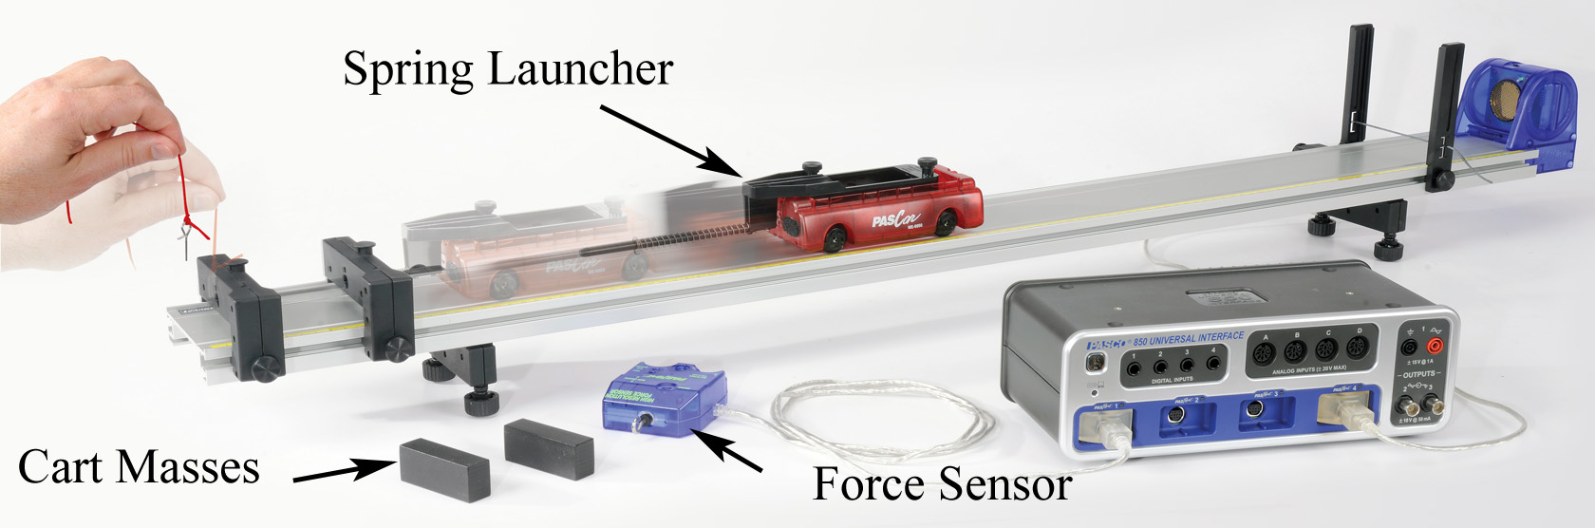

Figure 1: When the pin is pulled, the potential energy stored in the spring is released.Theory

When force is applied to a spring, the resulting extension or compression of the spring maintains a linear relationship with the applied force. This is called Hooke’s Law and can be written as

F = k Δx (1)

where F is the applied force, Δx is the extension or compression of the spring measured from its unstretched length and k is the spring constant.

The potential energy (U) stored in the spring is given by

U = ½ k Δx2 (2)

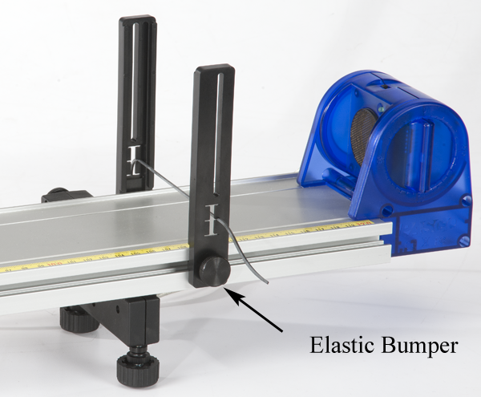

Setup

1. Attach the feet to the track, and then install the Elastic Bumper as shown in Figure 2, below. Attach the Motion Sensor and plug it into the interface. The range switch should be set on the "cart" icon. Later, if you have trouble getting good data from the Motion Sensor, try sliding the Elastic Bumper **closer** to the sensor.

Figure 2: Motion Sensor

1. Attach the Spring Launcher to the cart as shown in Figure 3. Use the strongest spring: It will have a small daub of black paint on one end. Note the orientation of the large end of the spring on the rod. Rotate the spring so that it catches and is attached to the support.

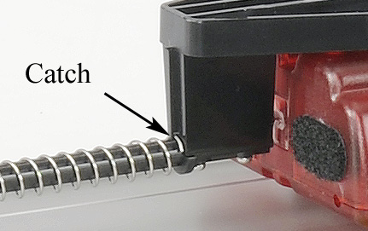

Rotate the spring so that it catches and is attached to the support.

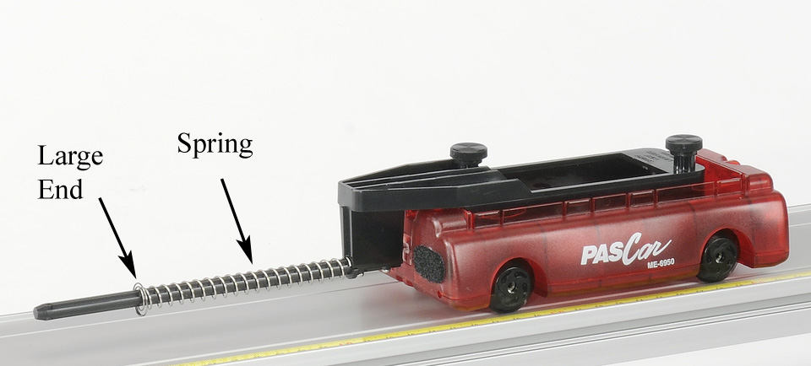

Figure 3: Spring Cart Launcher

1. Figure 1 shows two endstops in use for later in the experiment. For now, you will only use one endstop as shown in Figure 4. Push the rod from the spring launcher through the hole in the endstop and tie a loop of string through the small hole in the end of the rod.
2. Plug the Force Sensor into the interface. With the sensor flat on the surface of the track, press the zero button to tare the sensor. Hook it onto the loop of string as shown in Figure 4.
3. In PASCO Capstone, set the common sample rate to 100 Hz. Create a graph of Force vs. Time. Add a plot area and put the Position on the vertical axis of the second plot area.

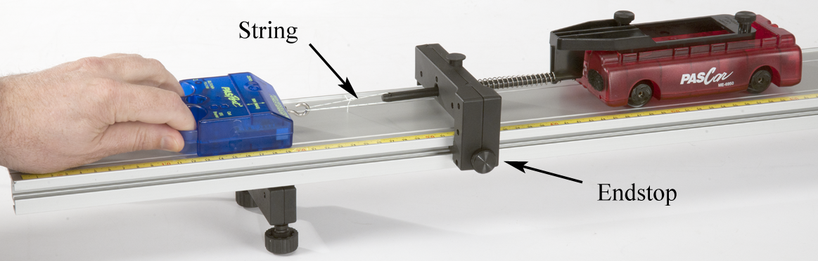

Figure 4: Finding the spring Constant

Procedure – Force and Position Data

1. Pull on the Force Sensor so that the spring is just barely in contact with the endstop.
2. Click on Record, and then slowly increase the pull on the Force Sensor, compressing the spring. Note the original position of the PAScar and move it 7 cm as the spring compresses (the coils of the spring should not touch each other).
3. If you are not getting good position data from the Motion Sensor, try sliding the elastic bumper **closer** to the Motion Sensor.
4. If your force data is not positive you can open the Data Summary and click on the properties icon (gear) for the Force Sensor. Note the check box to change the sign.
5. Once you are getting good data, delete all the preliminary runs.
6. Now repeat step 2, except this time slowly compress the spring by 7 cm, then slowly allow the PAScar to return to its original position and then repeat the compression and decompression one more time for a total of two full cycles.
7. Click open Data Summary and label this run as "Force Curve".

Spring Constant:

1. Create a graph of Force vs. Position and select the Force Curve run. Examine the Force vs. Position curve and answer Questions 1 and 2 in the Conclusion.
2. Record the slow 7 cm compression (as in step 2 on previous page.) Hold the spring at the 7 cm compression for about 15 seconds before stopping the recording. Click open Data Summary and label this run as "loading 1". Repeat twice more labeling the runs as "loading 2" and "loading 3".
3. Then do three unloading curves by first holding the spring compressed by 7 cm for 15 seconds and then recording as the tension is slowly released. Label the runs "unloading 1", etc.
4. Repeat step 9 except this time allow your hand to move faster to release the tension more quickly. Label as "fast 1", etc.
5. Create a table with three columns. Create User-Entered data sets called “Loading”, “Unloading”, and “Fast Unload”, all with units of N/m. Turn on the statistics with the mean and standard deviation.
6. Use a Linear curve fit on the force vs. position graph to find the slope of each of the nine lines. Use the Select tool to look at only linear areas of the graph, avoiding the beginning and ending of each run. Record your value in the table.

Spring Energy:

1. Create a graph of velocity vs. time.
2. Connect both endstops (about 9 cm apart) at the end of the track as shown in Figure 5.

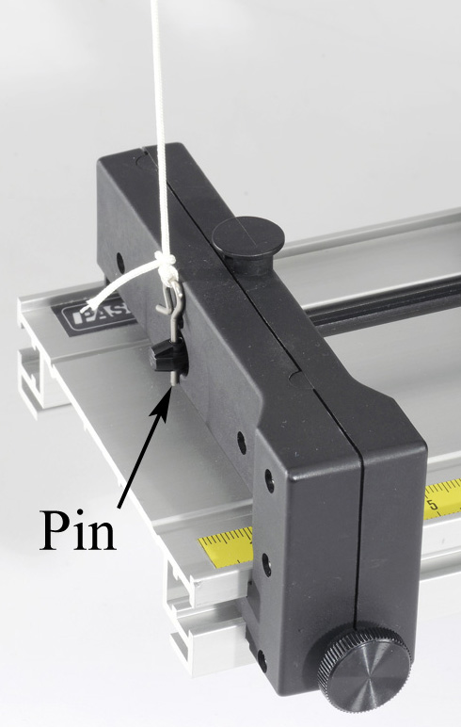 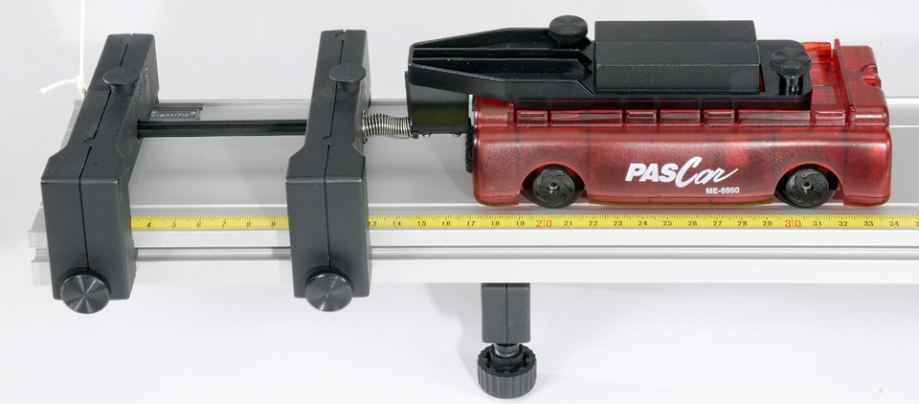

Figure 5. Compressed Spring Held with Pin

1. Adjust the separation so that when the spring is almost compressed 7 cm, you can place the pin into the small hole at the end of the rod.
2. Place both of the black compact masses in the cart as shown, but you don't need the spring compressed at this time.

1. Adjust the "level" of the track using the adjustable feet. Place the cart on the track and give it a small push towards the Motion Sensor. Click on Record. Your data will stop automatically when the cart is within 20 cm of the sensor.
2. Using the screw feet, adjust the level of the track so that the cart travels at a constant speed when moving **towards** the sensor. By setting up the track so that it is slightly downhill, you will be eliminating the effects of unwanted frictional forces. Label your final run as "flat run".

Measuring Compression:

1. Create a graph of Position vs. Time.
2. Use a balance scale to measure the total mass of "cart + launcher + extra mass".
3. Move the cart towards the Endstop until the spring is very slightly compressed. You want the Motion Sensor to measure off the end of the cart, so keep your hand in the middle of the cart, not hanging over the end.
4. Click on Record, then compress the spring until you can insert the Pin. Let go of the cart with your hand, letting the Pin hold the cart in place. Click on Stop.
5. Use the Coordinates tool (with Delta tool) to measure Δx, the compression in the spring.
6. Using Eqn. (2) and the mean spring constants you found earlier: calculate the energy stored in the spring using the loading data, and the energy recovered.

Kinetic Energy:

1. Looking at a graph of velocity vs. time, click on Record. Use the string to jerk the pin loose, and release the cart. You must pull upwards on the pin as quickly as you can. See Figure 1. There is a built-in stop condition that should automatically halt recording when the cart reaches the far end. Label the run "KE 1".
2. Repeat twice more.
3. Use the Coordinates tool to measure the max speed of the cart for each of the three runs and record below.
4. Calculate the mean speed.
5. Calculate the resulting kinetic energy of the cart using the mean speed.

Conclusions

1. Does the spring obey Hooke’s Law when it is compressed? Explain fully! Is this surprising?
2. Does Hooke’s Law appear to hold for any portion of the curve?
3. Can you explain the difference between the between the loading and unloading force curves in terms of friction in the system? Hint: consider the little "tail" on the loading force curves as the cart was held motionless for 15 seconds and the beginning tail on the unloading curves when the cart was released.
4. How well does the potential energy stored in the spring agree with the kinetic energy gained by the cart? Discuss fully!